Announcing the L&C Essay Competition
For Rules – claudiadcrump@gmail.com
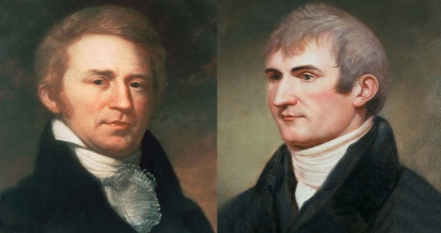Whose ESSAYS will fill these pages?
Flag Raising 1803
Handshake Statues
Blue Beads
Freebies and Prizes
Water – No Food
Storytellers
Scouts and Rangers
??? Q and A ???
Authors
Musical Highlights
Play – Great L&C Camp Out Play Simulations
History Galore and More…
Handshake Sponsors
Thanks to
*Trail Heritage Foundation
*Ohio River Chapter
*L&C Expedition Foundation
*IN Department of Natural Resources
*Center for Cultural Resources
*Hennings Museum
*Colgate Baptist Church
*RSVP
*Rock Creek Community Academy
*And 50+ Volunteers
Would you like to join us?
Announcing the L&C LOGO Competition
For Rules – claudiadcrump@gmail.com
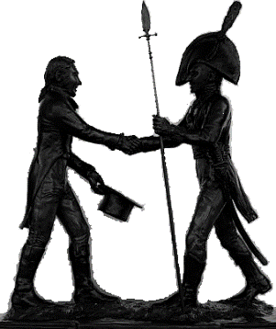
Whose LOGO will be here?
Lewis & Clark Handshake
Saturday, October 2
10 AM- 4 PM
Map and Parking Instructions Accessible at Colgate Baptist Church
2021
Falls of the Ohio Interpretive Center
Clarksville, Indiana
Over for Program Planning with the Clock

Lewis and Clark Handshake Planner…
Fill in your clock for a Full Handshake Day – 10 AM to 4 PM – on Saturday, October 2, 2021 – at the L&C Handshake Event
Do Not Drive to Falls Center -- Go to Colgate Baptist Church (across from the Clarksville Aquatic Center) for Street Parking Maps
Event Located at the Falls of the Ohio Interpretive Center
How can I try all 20 activities from 10am to 4pm? You can’t. Check all you most want to visit; allow 20-30 minutes for each by drawing lines to you clock. Attending the L&C “Camp Out” play at either time will take about 2 hours. Now fill in with other activities. Plan a good full day by counting your minutes of the Red Clock. Handshake Criers and big Signs will alert you to beginning times for most sessions. Have fun while learning about the L&C Trail Challenges and Successes.
Recommended audiences CHILD YOUTH ADULT FAMILY
FLAG-RAISING of 1803– 10:00-10:20 – Statue Circle—Captain Lewis impersonator-Skip Jackson

For ACTIVE PARTICIPATION …….
*HANDSHAKE STATUES 1st Edition Model and Stories of the Sculptor – Sorry No Handshaking – All Day – Statue Circle at Entrance
L&C ESSAY CONTEST and INTERVIEWS – All Day – Rotunda with Hennings Museum
VISIT THE HENNINGS MUSEUM transported from Michigan – Trail Artifacts and What and Why Would You Take on the Lewis & Clarks Corps Journey?

MINGLE WITH POPUP LEADERS for Q&A and Blue Bead Competitions – All Day and All Places
INTERVIEW THE BLACKSMITH FOR ROLES OF IRON TOOLS ON THE TRAIL – All Day – Lawn

SHOP AND INTERVIEW THE WEAVER – All Day – Lawn
For MORE ACTIVE PARTICIPATION ……
YORK – LIFE OF CLARK’S SLAVE – 10:30-11:25 – Theater
CHAT TRAIL SLIDE SESSION on Teaching L&C Series of 4 continuing and optional sessions on WHY, WHAT AND HOW TO TEACH L&C with Perceptions of People and Places –10:30-3:30
Chart Room #1 SIMULATION: MOVING THE CLARKS WEST – River Room – 10:30-11:00
MUSICAL PREVIEW FOR PLAY – 12-12:30 and 2:00-2:30 – Front Patio
THE GREATEST AMERICAN CAMP OUT – Original Play by Rock Creek Academy Teacher-Author and Students – 2 performances 12:30-1:45 and 2:30-3:45 – Theater
EARN SIGNED CERTIFICATES FOR PARTICIPATION and visits to the Prize Table with many choices and many prizes – 11:00-3:30 – Rotunda and Patio
EVEN MORE ACTIVE PARTICIPATION!
MOVING VAN – COVERED WAGON WORKSHOP – 11:00-11:30 Bird Room
PHOTO-POSING with L&C Panels All Day

VOTING FOR LEWIS & CLARK LOGOS that best tell the L&C Story – Voting All Day in Pop-Up Tent at Entrance
WALKING THE TRAIL – 10 Historical MARKERS & MAPS – Simulations of Major Trail Challenges – All Day – Lawn Earn blue beads at each marker
DANCE & CLAP WITH ROVING MUSICIANS All Day and All Places – Rotunda Gazebo -Lawns
VIEW AND BUY RECOMMENDED L&C BOOKS Child, Youth and Adult – All Day – Rotunda

