Greenville Elementary School
2018-19 SUPPLY LIST

Kindergarten
1 pack of washable Crayola markers,
broad line or fine
1 highlighter chisel tip, any color
1 binder, 3 ring, 1” heavy duty,
clear view on the front
2 Folders, Poly, 2 pocket with front view cover,
with prongs, any color
1 box facial tissue
1 pencil pouch, 3 ring hole punched
1 Earbuds or headphones that fit your child best,
with a 3.5mm jack
1 box of baby wipes (girls)
1 pk of white card stock, 8.5x11”,
100 sh/pk (boys)

1st Grade
8 Black Dry Erase Markers, chisel Tip Expo
1 Pkg. Wipes, Disinfecting
2 Dz. Pencils #2, Ticonderoga, Sharpened
3 Glue Sticks, washable, white
1 Pr Scissors 5”, Blunt tip
2 Boxes Crayons, 24/Box
1 Folder, Poly, 2 pocket, Green
1 Folder, Poly, 2 pocket, Blue
1 Pencil Box
1 Box Facial Tissue
1 Pkg. Eraser caps
1 Card stock, white 8½ x 11 (girls)
1 Card stock, colored 8½ x 11 (boys)
1 Storage Bags, Zip, Gallon, (boys) 30 count
1 Storage Bags, Sandwich (girls) 100 count
1 Headphones

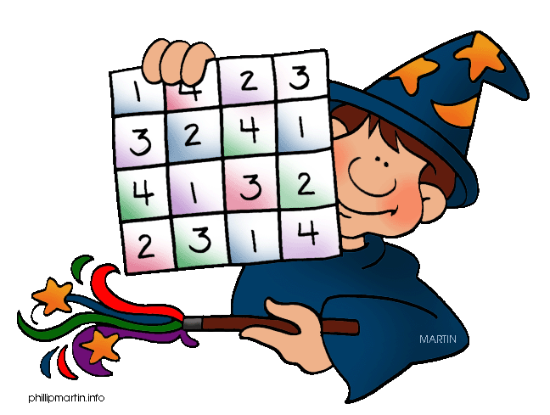

2nd Grade
1 pk Folders, poly 2 pkt/prong, 4 pk,
Be/Rd/Gn/Yw
2 boxes Crayons, 24/Box
3 Dz. Pencils #2, Ticonderoga, Sharpened
1 Pr. Scissors, 5”, pointed tip
4 Glue Sticks, Elmer’s
1 Pencil Box
2 Facial Tissue
1 Binder, 3 ring, heavy duty, view 1” NOT white
3 pk Erasers, pencil cap, 12/pk
2 Highlighters, Chisel Tip, Yellow
Notebooks, Spiral, 2 pk. Wr, 70 ct, Blue/Red
1 Folder, 2 pocket, w/prong.
1 Box Storage Bags, Economy zip,
Sandwich (Boys)
1 Box Storage Bags, Economy Zip, Gallon (Girls)
1 Hand Sanitizer, antibacterial, gel (Boys)
1 pk. Wipes, antibacterial, (Girls)
1 Earbuds w/case/headphones
4 Black Fine Tip Expo Dry Erase Markers

3rd Grade
1 Stick-on Notes, 3” x3”, Yellow, 100 sht/pd,
1 pack 3x3 post-its
Folders, poly, 2 pkt/prong, 4 Bl/Be/Rd/Gn/Yw
2 Binder, 3 Ring, Heavy Duty, 1” White,
clear front pocket
1 Box Crayons, Crayola, 24/Box
2 Dz. Pencils, #2
1 Pr Scissors
6 Glue sticks, Elmer’s
1 Bottle of glue
1 Pencil Box
2 Notebooks, 1 Sub, wide rule,
one black/ one blue
2 Boxes Tissue
1 Storage Bags, quart
2 Erasers, pink
1 Markers
2 Highlighters
1 Composition Book, wide rule
1 Dividers, 5-tab
1 Wipes
1 Headphones
1 3-ring pencil pouch
1 12 oz. bottle of hand sanitizer (over for 4th gr.)

4th Grade
1 Eraser, pink, large
1 Pkg. Baby Wipes 80 ct
2 doz. Pencils, #2, Sharpened
1 Scissors 5”, pointed tip
1 set Pencils, colored, 7”, sharpened, 8/set
2 Glue Sticks
4 Notebooks, wr, 70 ct, blue/red/grn/yellow spiral
2 Boxes Facial Tissue
2 each Markers, Dry Erase, fine tip, black
1 Binder, 3 ring, heavy duty, view, 1.5”, white
1 Pencil Box, plastic,
2 Pens, stick medium point, red
1 Binder, 3 ring, economy, 1”, red
1 Binder, 3 ring, economy, 1”, black
1 Highlighter, chisel tip, yellow
1 Earbuds w/case

If you wish to order a supply kit from Harcourt, orders are due by April 27, 2018 to:
Greenville Elementary PTO or order online at
www.harcourtbacktoschool.com
click on STORE
enter school code gvbtsp2018
Visa, MasterCard, Discover accepted online.

